**Simpson Collage Instructions**

**Cutting images out**

1. Open Photopea, select Open from computer, and find your photo in your student folder (photos you want to cut out). Stretch the image to fit the screen.
2. 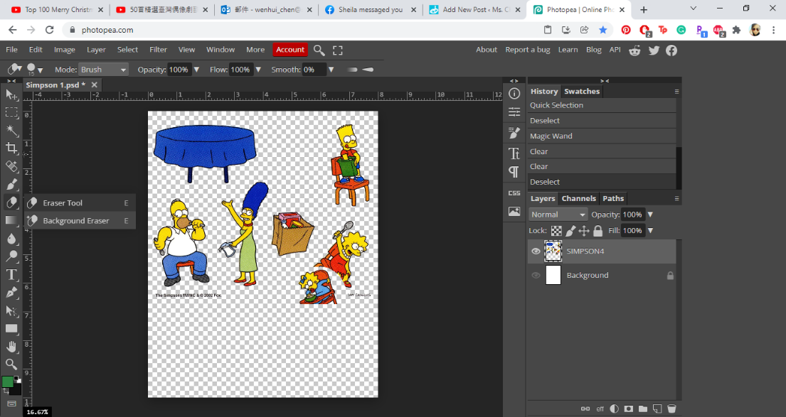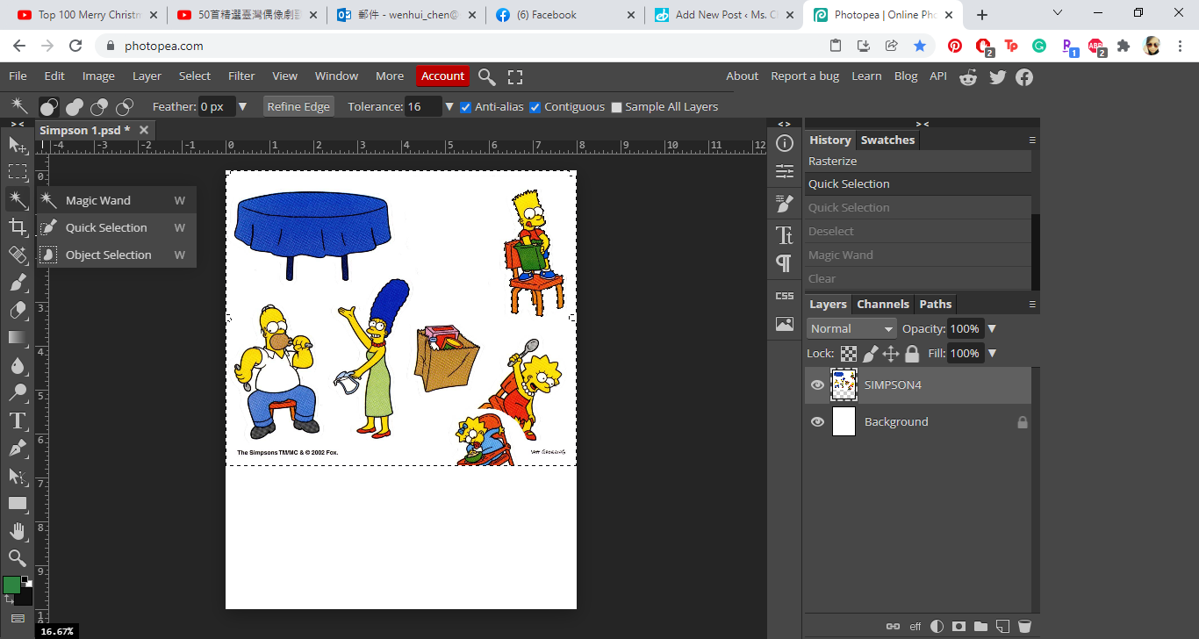Use the Magic Wand and select the white background and press Backspace to remove background. You should be left with a checkered background, this means it is transparent.
3. Select the Erase tool to erase other images and keep the image you want.

Right click to select the eraser size.

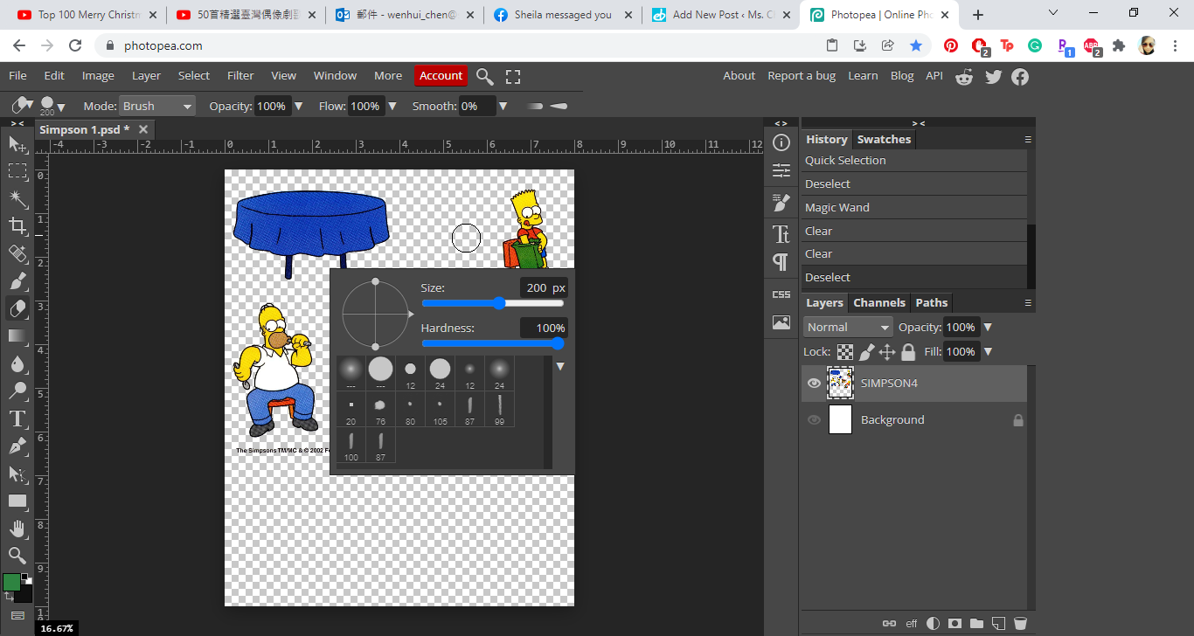

1. Click Crop to narrow down the photo and press enter.

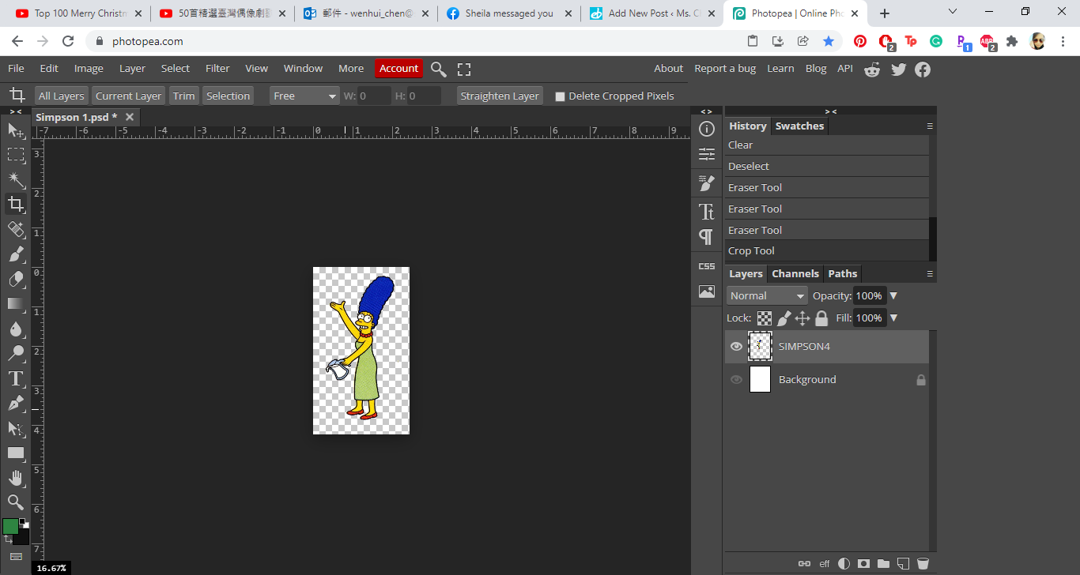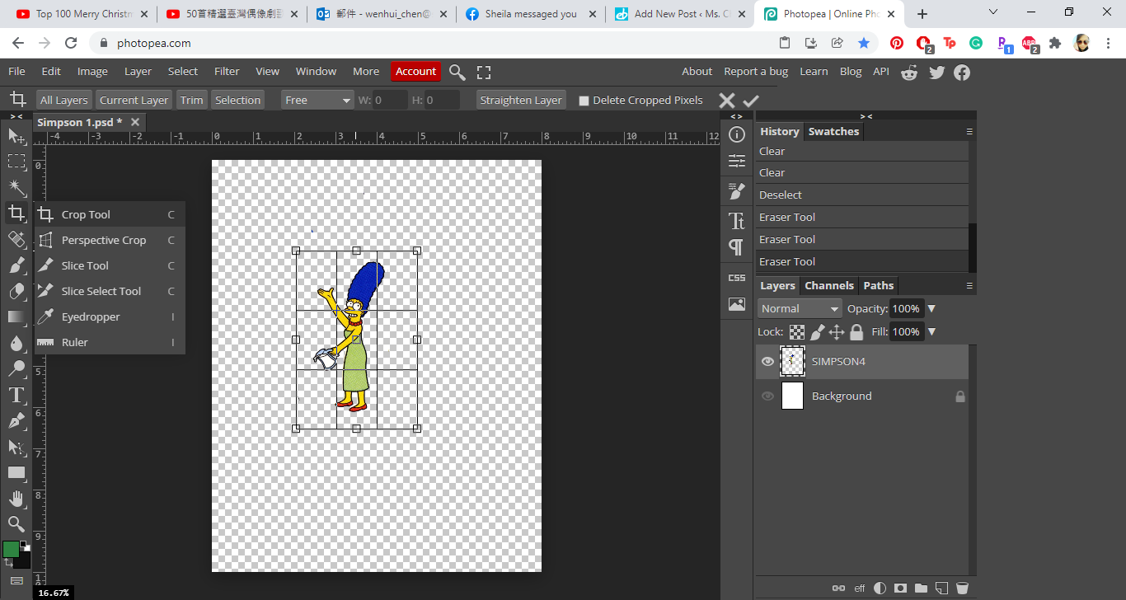

1. Click File, and Save As. Save in your ONEDRIVE (Simpsons) and name it “Margret”. Make sure the file type is “PNG”.

**Repeat the steps to get your images cut and saved. You need at least 5 images per collage.**

1. 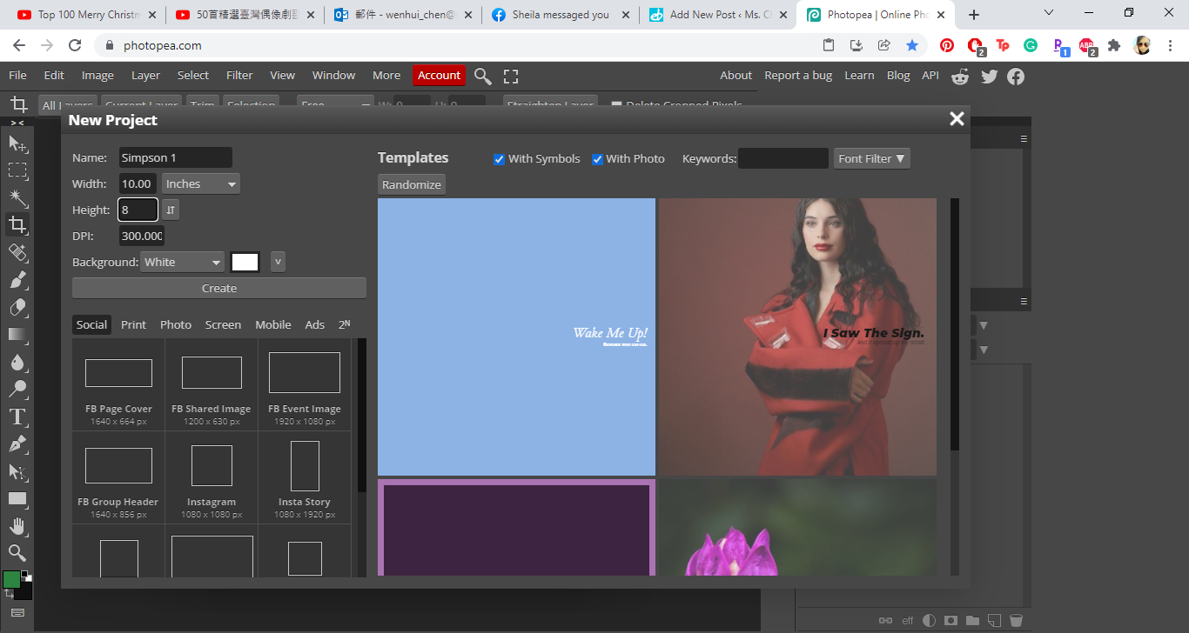Open Photopea, select NEW PROJECT, and set your canvas dimensions to:

Name: Simpsons 1

Width: 10 inches

Length: 8 inches

Resolution: 300dpi

1. 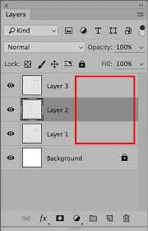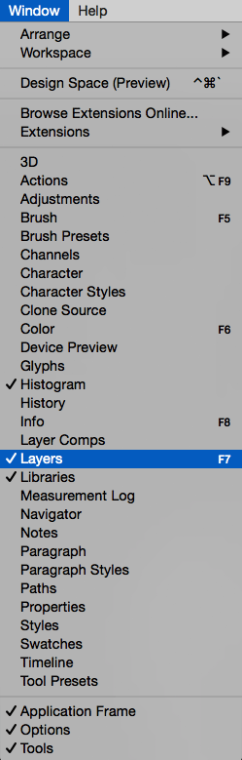Go to WINDOWS and open Layers. (This way you can see all the layers you want to work on)
2. Select Open and Place, and find your background photo in your ONE DRIVE folder. Stretch your background to fit the canvas.

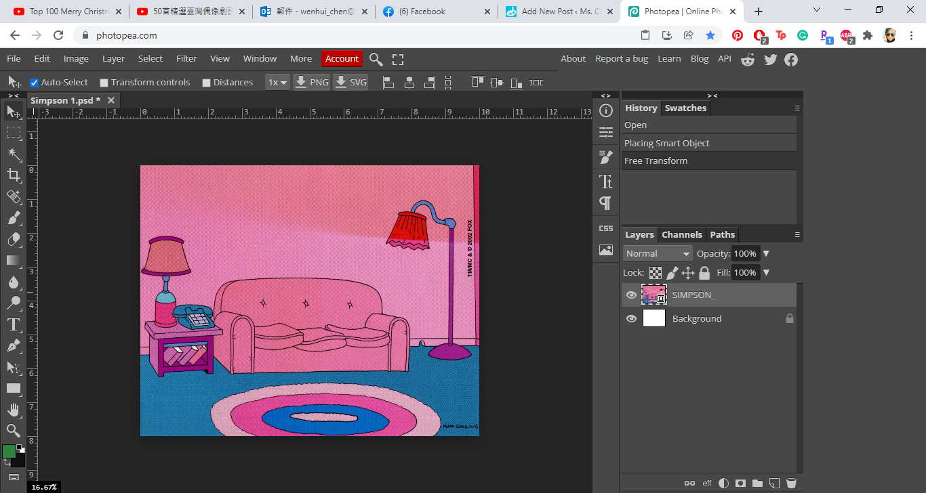

1. Select Open and Place, and find the cut out photos in your ONE DRIVE folder. Rasterize all of the cut out images.
2. Place the images where you want it. Play with layers to get images in front/behind another. Erase part of images to make it look like it’s coming out of something.

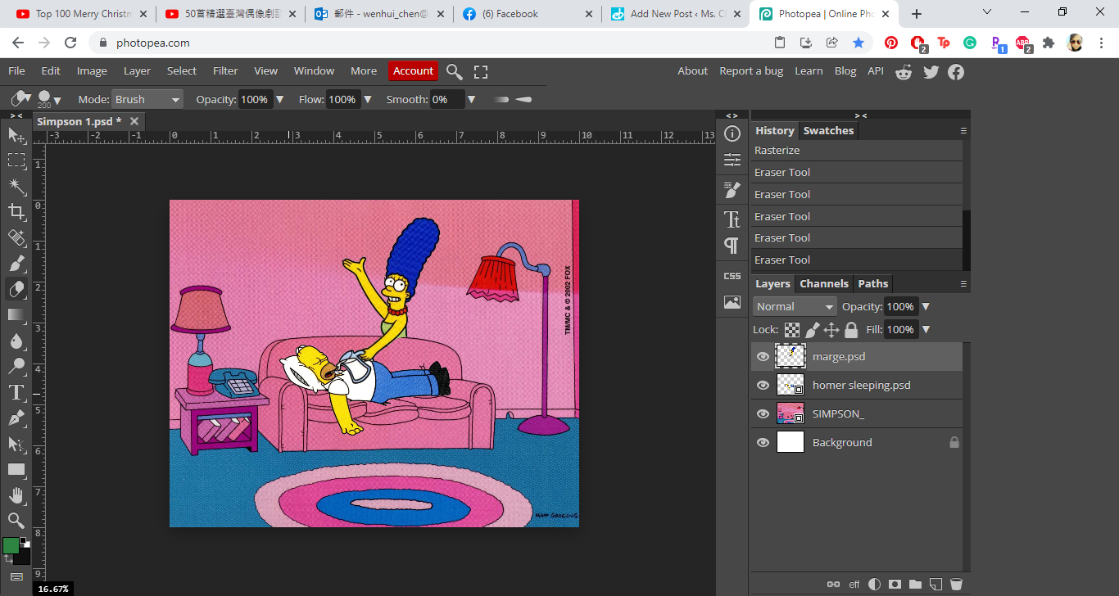

*** If you are going to work on the project more, make sure you save the project in Photoshop (PSD) File Type. PSD fill allows you to go back and rework on it. It is recommended to save one even when you are finished so if you ever need to do touch ups, you don’t need to restart the whole thing.

*** If you are completely finished with the project, save it in JPG File Type. (Once you save it in this file type, there is no going back to make adjustments)

1. **File 🡪 Save As** (if you are saving this project for the first time), and save to your Simpson folder. Name it Simpson Project.

**File 🡪 Save** (If you are updating the project this time.)